Machine Description | Blueprint is a TryHackMe machine where initial access is achieved via a vulnerable web application or API endpoint that allows unauthenticated command execution or file upload, followed by credential discovery and local privilege escalation to root or SYSTEM.
Target IP | 10.201.12.9
Vulnerability Name | Unauthenticated Remote Code Execution (RCE) leading to credential disclosure and local privilege escalation
Service /Version | TCP / 8080 HTTP Apache ( oscommerce 2.3.4 )
CVSS Score / Severity | 9.8 Critical
Attack Vector | CVS3.0: AV:N/AC:L/PR:N/UI:N/S:U/C:H/I:H/A:H
Proof Of Concept | STEP 1 – Add target IP to local Host config file so it can resolve domain locally  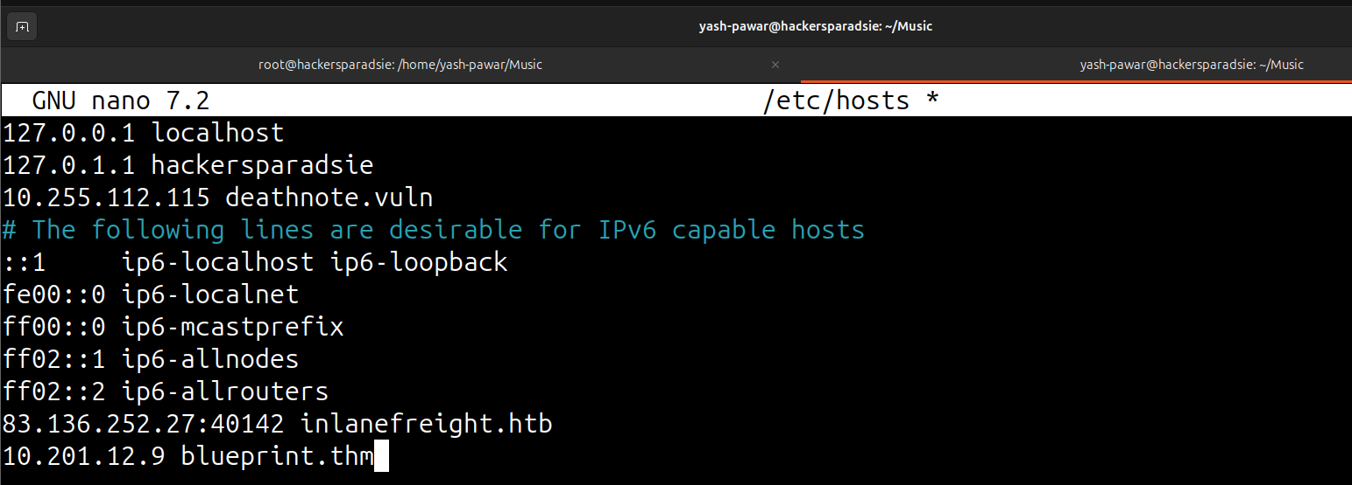  STEP 2 – Scan for open ports and services on the target system using Nmap  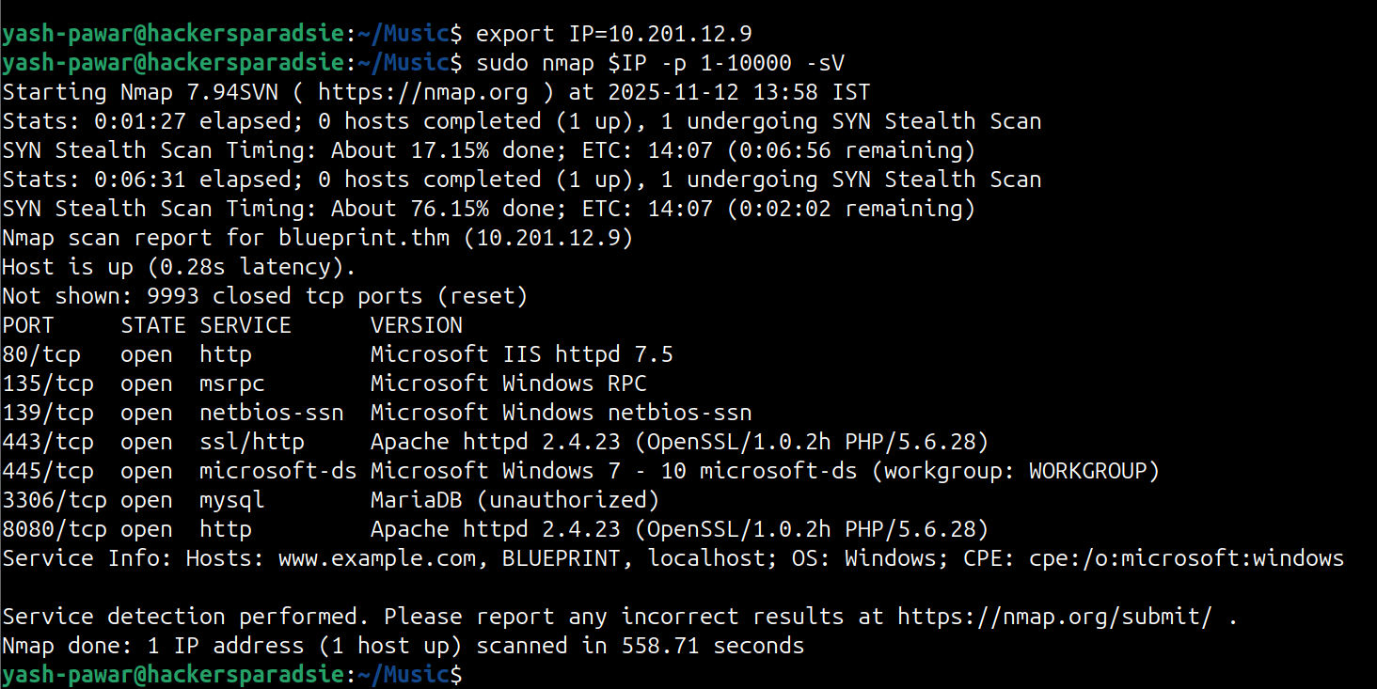  STEP 3 – We Have HTTP Apache server running on target 8080 Let’s Enumerate it.  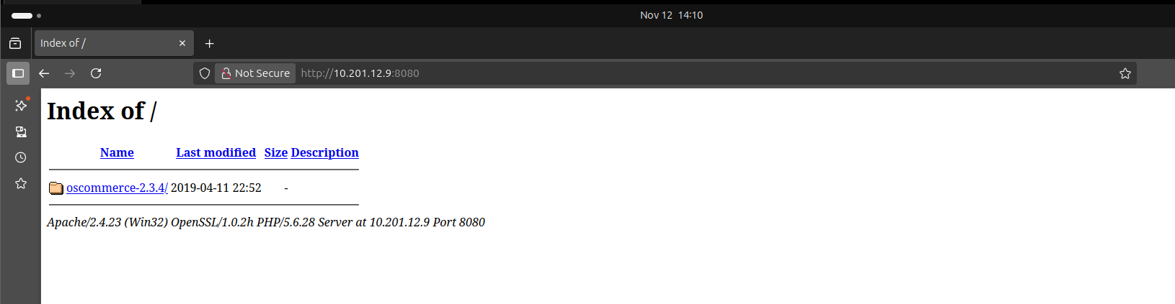  - Indexing is available on the server  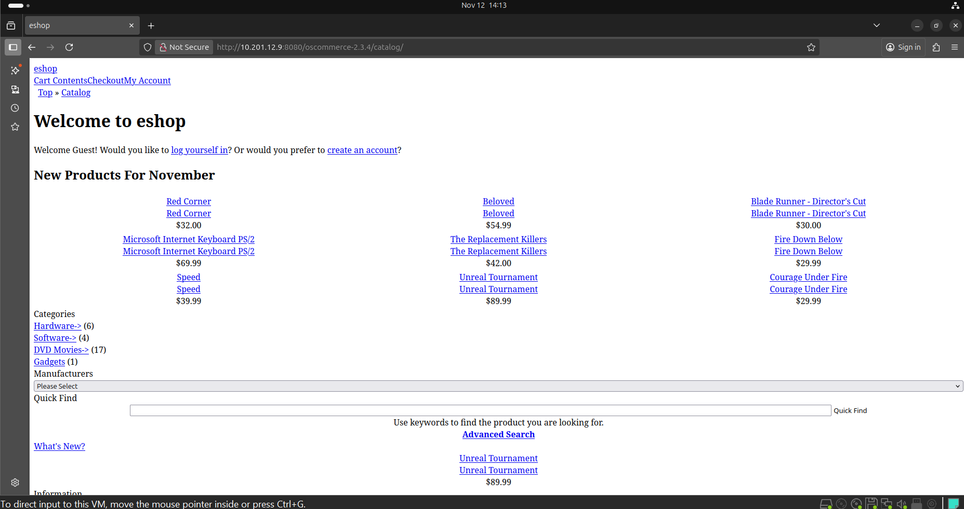  STEP 4 – Lets Look in exploit DB if we have any relevant exploit for the version oscommerce 2.3.4  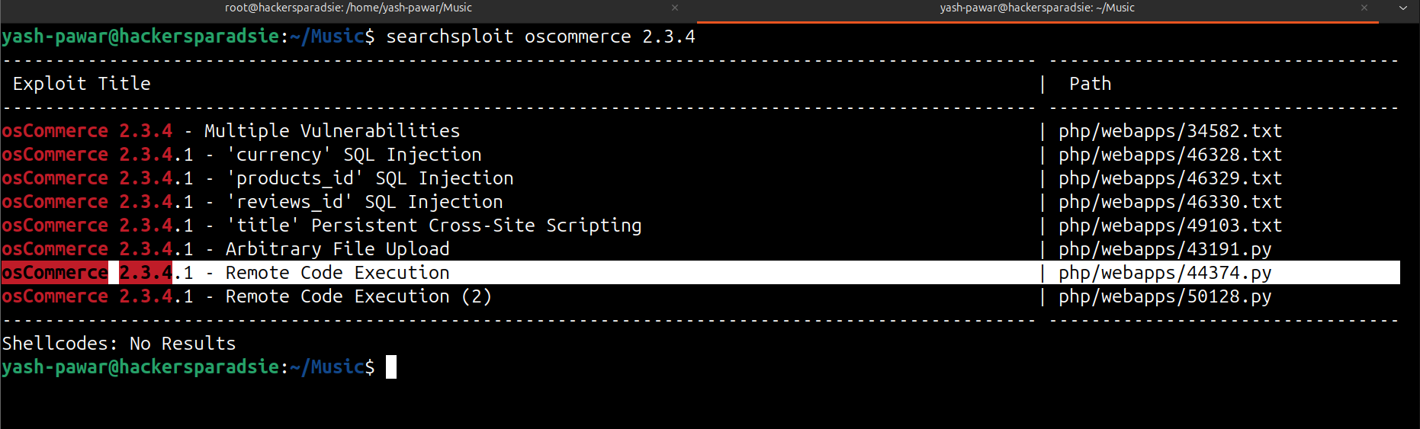  - Let’s configure it or we can use Metasploit exploit modules  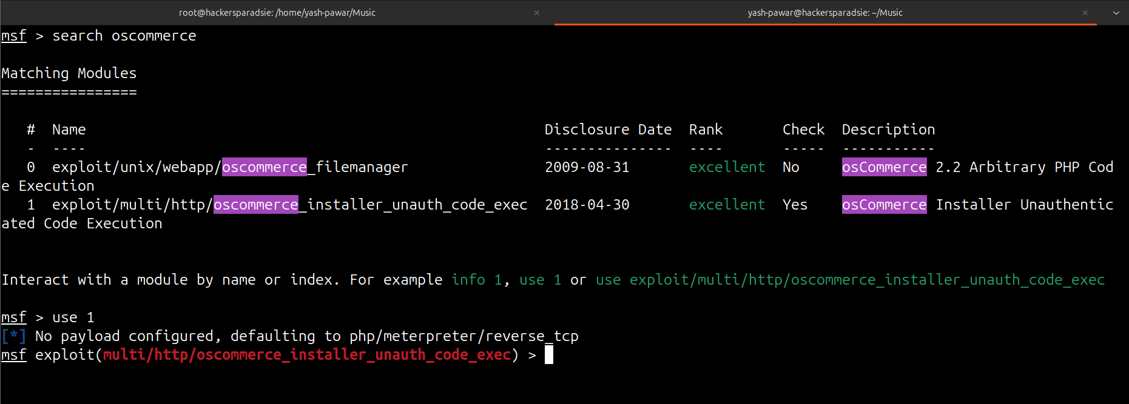  - See options and run the module  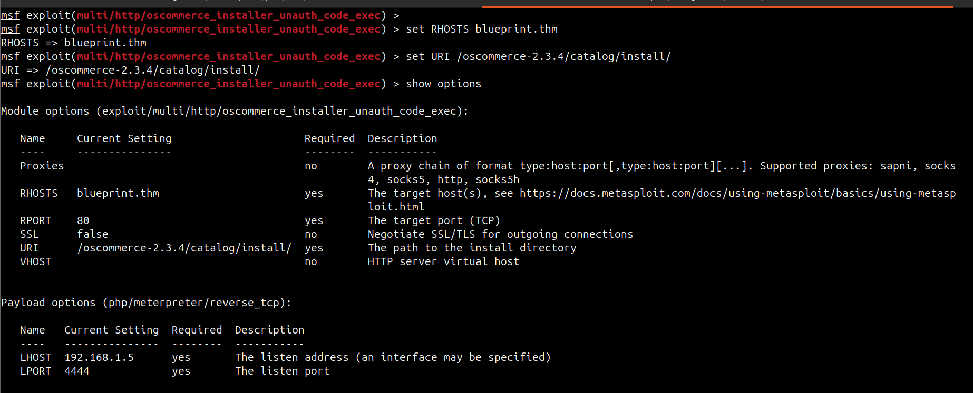  - We got Meterpreter on target  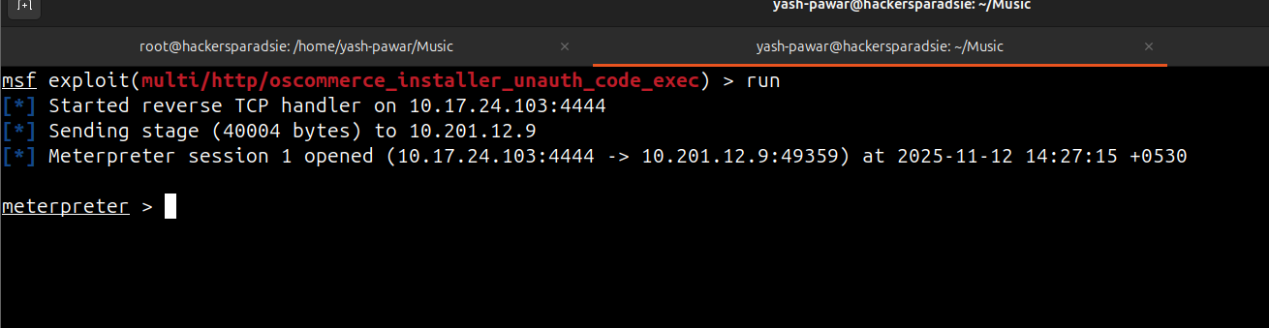  STEP 5 – Try to dump hash and crack it using Crack station  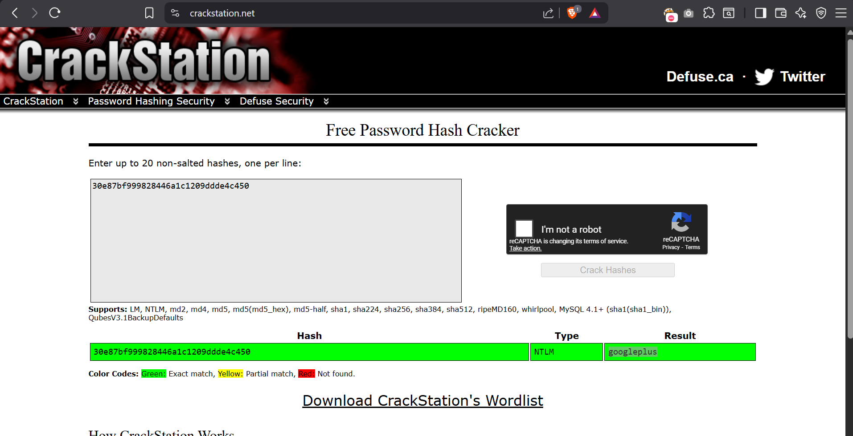  STEP 6 – Grab root flag  Which is at : C:\Users\Administrator\Desktop
Impact | - full remote command execution allowing arbitrary code and lateral actions.  - credential disclosure enabling authenticated access and persistence.  - local privilege escalation resulting in complete system compromise.  - potential data exfiltration and long-term backdoor installation.
Remediations | - remove unauthenticated execution paths; validate and sanitize all input.  - restrict file uploads with strict whitelisting, scanning, and run uploads outside Webroot with least privilege.  - eliminate plaintext credentials from code and config files; use secrets management and rotate exposed credentials.  - audit Sudoer’s and SUID binaries; apply least privilege and patch vulnerable services.  - implement network segmentation and monitor anomalous outbound connections.
Reference | https://tryhackme.com/room/blueprint

